**Silver City Wetlands Action Plan**

**March 2008**

Prepared by New Mexico Environment Department Surface Water Quality Bureau

With review and comment from:

Town of Silver City

Southwestern New Mexico Audubon Society

Gila Native Plant Society

Gila Conservation Education Center

The Nature Conservancy

WNMU Department of Natural Sciences

Grant Soil and Water Conservation District

Gila National Forest

US Fish and Wildlife Service

**Introduction**

Cienega is the Spanish word for marsh, swamp, bog, or wetland and, prior to becoming the Town of Silver City, the Silver City area was known as La Cienega de San Vicente. La Cienega de San Vicente was located at the lower end of a 38 square mile watershed where Silva Creek and Pinos Altos Creek come together and form San Vicente Creek (Image1). San Vicente Arroyo is the major western tributary to the 5,000 square mile Mimbres Watershed. The earliest settlers at La Cienega de San Vicente engaged in small scale agricultural activities in support of mining operations in the Pinos Altos Mining District located five miles to the north. Silver ores were subsequently discovered at nearby Boston Hill and Chloride Flat and what remained of the old cienega became part of Silver City. Historic practices like agricultural, mining, livestock grazing, and urbanization severely impacted wetlands and riparian vegetation in this small watershed.

Some areas have recovered from historic impacts but impacts from urbanization and invasive non-native species are continuing threats to ecological integrity that must be addressed. Opportunities still exist to protect the remaining riverine wetlands and riparian habitats and to restore ecological functions that have been lost, such as flood flow dissipation, ground water recharge, wildlife habitat, and improved water quality and perennial base flow.

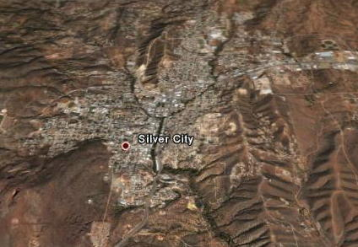

(Google Earth Image)

**Image 1.** Birdseye view looking north at the Town of Silver City. The dark green “Y” shape in the center of the photo is formed by Pinos Altos Creek (on the right) and Silva Creek (on the left) converging to form San Vicente Creek.

**Wetlands Action Plans**

A “Wetlands Action Plan” is a planning document designed specifically to address wetlands within the boundaries of a specific watershed. Wetlands and riparian areas have ecological, economic, and aesthetic value and serve many vital functions including water purification, storage, and erosion reduction. Riverine wetland and riparian vegetation store storm water runoff increasing the duration of stream base flows, stabilize stream banks thus reducing erosion, improve wildlife and fish habitat and overall ecological conditions. A Wetland Action Plan provides guidance on protecting and restoring wetland functions with an emphasis on conserving habitats of threatened and endangered species, migratory birds, and other species of concern.

This Wetlands Action Plan will become an addendum to the Watershed Restoration Action Strategy (WRAS) that covers watersheds in the Mimbres Watershed. The Mimbres Watershed WRAS lists specific water quality problems; identifies sources of contamination causing those problems; and a schedule of actions items to abate water quality problems along with estimated funding requirements. A WRAS is a non-regulatory, voluntary approach to perform these actions. The New Mexico Environment Department Surface Water Quality Bureau (SWQB) is providing guidance to facilitate watershed groups throughout the State to develop “Wetlands Action Plans” as an additional component of their WRAS.

Wetlands are “those areas that are inundated or saturated by surface or ground water at a frequency and duration sufficient to support, and that under normal circumstances do support, a prevalence of vegetation typically adapted for life in saturated soil conditions” (U.S. ACE 1987). Wetlands generally include swamps, marshes, bogs, fens and similar areas; and lands that are transitional between terrestrial and aquatic systems where the water table is usually at or near the surface of the land. Wetlands must have one or more of the following attributes: (1) at least periodically, the land predominantly supports hydrophytes (plants dependent on saturated soils or a water medium); (2) the substrate is predominantly undrained hydric soil; and (3) the substrate is non-soil and is saturated with water or covered by shallow water at some time during the growing season of each year.

The upland limit of a wetland is the boundary between land that supports predominantly hydrophytic cover, soil types that are predominantly hydric, and evidence of hydrology that supports wetlands and land with predominantly mesophytic or xerophytic cover, soil that is non-hydric and land that is not saturated or flooded some time during the growing season. The lower boundary between wetlands and deeper water habitat associated with riverine and lacustrine systems lies at 2 meters (6.6 feet) below low water, or the maximum depth at which emergent plants normally grow.

Riparian areas are also included as part of the analysis. Riparian ecosystems are characterized by phreatophytic and mesophytic vegetation and habitats associated with bodies of water and dependent on existence of perennial, intermittent or ephemeral surface and subsurface drainage.  The strict water requirements of wetlands are not as drastic in riparian areas however they occupy the same areas of the landscape, may contribute to the same functions within the landscape, and are interdependent, and therefore should be considered together during the assessment phase of the Wetlands Action Plan development.

**Geography and Geology**

The Silver City Watershed is located within the much larger Mimbres Watershed (Appendix A Silver City Watershed Map). The Silver City Watershed is bounded by the Continental Divide in the Pinos Altos Mountain Range to the north and by the Continental Divide to the west in the Silver City Mountain Range. A low topographic divide on a bedrock bench forms the eastern boundary and deep bolson deposits form the southern boundary. From east to west the principle watercourses are Maudes Canyon, Pinos Altos Creek, San Vicente Creek, Cottonwood Creek, Little Walnut Creek and Silva Creek. Cottonwood Creek and Little Walnut Creek are tributaries to Silva Creek. Maudes Canyon, Pinos Altos Creek, and Silva Creek are tributaries to San Vicente Creek. The watershed considered under this plan would terminate at the discharge point for effluent from the Silver City Waste Water Treatment Plant.

The Town of Silver City estimates the current population at 10,545 and the median household income at $25,000 (Town of Silver City website 2006). The high rate of development and growth in Silver City is expected continue and the present window of opportunity to protect wetlands and riparian areas in the Silver City may not last long.

Southwestern New Mexico’s climate is usually described as semiarid. Average annual precipitation in Silver City is about 17 inches. Approximately one half of the annual precipitation falls during the summer thunderstorm season from early July through mid-September. Summer precipitation from thunderstorms is derived from a seasonal shift in wind direction allowing a moist flow of air to enter New Mexico from the south. Winter precipitation as rain or snow from December through April is mostly derived from low-pressure storm systems originating in the Pacific (Appendix B Climate Data).

The Silver City Watershed includes three ecoregions – Chihuahuan Desert Grasslands (24b), Madrean Lower Montane Woodlands (23b), and Montane Conifer Forests (23c). The elevation ranges from about 5,800 feet in the south to 8,000 feet in the northwest at the summit of Bear Mountain.

The geology of the Silver City Watershed includes older sedimentary rock overlain and intruded by younger igneous rock (Cunningham 1974). The Pinos Altos Mountains to the north are a complex mix of Paleozoic limestone, shale, and sandstone intruded by Tertiary quartz monzanite and granidiorite. The Silver City Mountain Range to the west of town is a northwest trending tilted fault block of Paleozoic limestone, shale, and sandstone. Most of the town and much of the watershed lie on a low bedrock bench of intruded igneous rock with much younger deep basin fill of sand, gravel, and conglomerate to the south. These varied types of rock are the parent material for the many different types of local soils.

The New Mexico Natural Heritage Program examined soils at four sites in the Mimbres Watershed as part of a survey of riverine wetland and riparian vegetation communities and identified Entisols, Inceptisols, and Mollisols as soil orders most closely associated with wetlands and riparian areas. More detailed classification and extent of coverage is provided in the Soil Conservation Service (now Natural Resource Conservation Service) Soil Survey of the central and southern parts of Grant County (Parham 1983). Table 5 in the Soil Survey indicates that Manzano, Paymaster, Ellicott, and Stirk Varient are the only soils that rate from fair to good for potential for wetland plants. A description of these soils for the Silver City Watershed is presented in Appendix C Soils. However the soil maps for the Silver City Watershed combine some of these soils into complexes or associations consisting of two or more soils. More detailed mapping within the creeks would probably identify additional soils with potential for wetland and riparian vegetation.

Upland soils in the Silver City Watershed are generally thin and consist of poorly developed mineral soils. Alfisols occur in the northern and western higher elevations of the Gila National Forest. Aridisols are present in the southern lowest elevations of the watershed.

**Local Hydrogeomorphic Conditions**

Local watershed characteristics are typical of southwestern New Mexico exhibiting highly variable flow conditions. Stream flows are primarily dependant on precipitation events and subsequent runoff with minor contribution to flows from groundwater. High flows are usually the result of intense localized summer thunderstorms. Runoff from winter rains and melting snow occur most years but rarely create large floods in this watershed.

Interrupted streams can include perennial, intermittent, and ephemeral flows (Meinzer, 1923). What generally passes for perennial streams in southwestern New Mexico are perennial reaches of interrupted streams sustained by fair weather runoff (base flow). Base flows in streams are composed largely of groundwater effluent (Langbein and others 1947). Streams originating in the mountains make a transition from bedrock-dominated substrates in the uplands (which tend to insulate streams from groundwater) through middle elevation areas with mixed terrain consisting of shallow alluvial deposits confined by bedrock (which tend to support interrupted streams). After making the transition through the mixed terrain, the streams finally reach the lower terrain consisting of desert basins dominated by thicker bolson deposits (where streams may completely enter the groundwater to become ephemeral on the surface). Most of the small watercourses in the Silver City Watershed are best described as perennial interrupted and, although interrupted, these streams commonly support obligate aquatic life and small riverine wetlands. A preliminary inventory of riverine wetlands and riparian resources in the Silver City Watershed follows:

**Maudes Canyon** is a perennial interrupted stream that drains the eastern part of the Silver City Watershed before entering San Vicente Arroyo near the downstream boundary of the watershed (Image2). The upper section of Maudes Canyon (north of US Highway 180) includes the southeastern part of the Pinos Altos Mining District but the dominant land use has been livestock grazing and wood cutting for more than 125 years. Numerous earthen stock tanks in the ephemeral watercourses feeding Maudes Canyon have been constructed for livestock watering but many of the tanks are no longer functioning due to lack of maintenance. Maudes Canyon is mostly private land and the lower section (south of US Highway 180) is dominated by residential development. During the past decade residential subdivision has been increasing in the upper section. Wetland and riparian resources are generally confined to the main stem of Maudes Canyon.

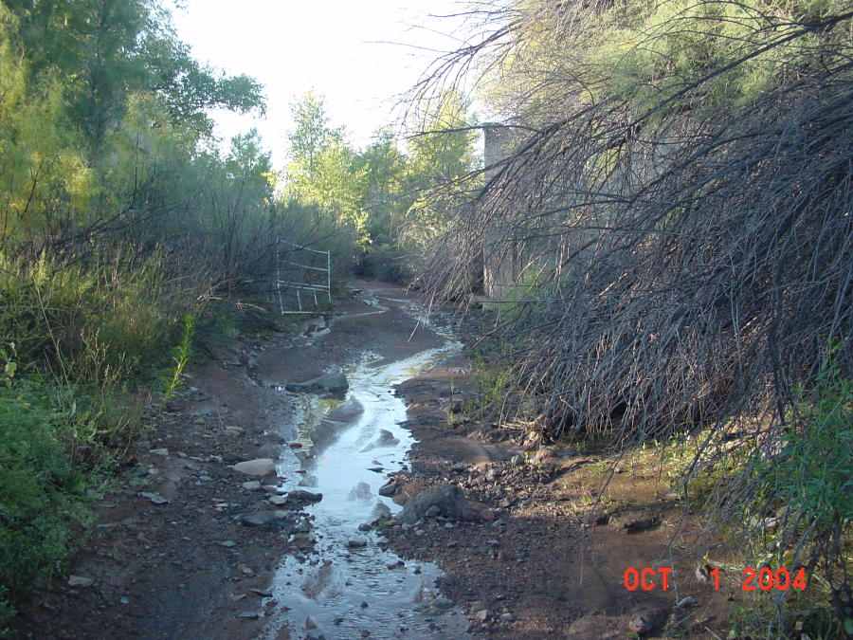

(NMED SWQB Image)

**Image 2.** View of Maudes Canyon looking south from State Trust Land located north of US Highway 180.

**Pinos Altos Creek** is a perennial interrupted stream immediately west of Maudes Canyon (Image3). Overgrazing, extensive wood cutting, and mining activities were serious impacts over the past 125 years but the primary land use today is residential housing. The old Hearst Mill site is located along Pinos Altos Creek within the city limits. The EPA initiated some cleanup efforts in the early 1990s but the site remains undeveloped due to contaminated mill tailings still on site. The lower section (south of US Highway 180) is deeply incised with residential and commercial development immediately adjacent to the stream banks. Despite draining a small area, Pinos Altos Creek has a relatively long reach of perennial water and some of the best remaining wetland and riparian resources remaining in the Silver City Watershed.

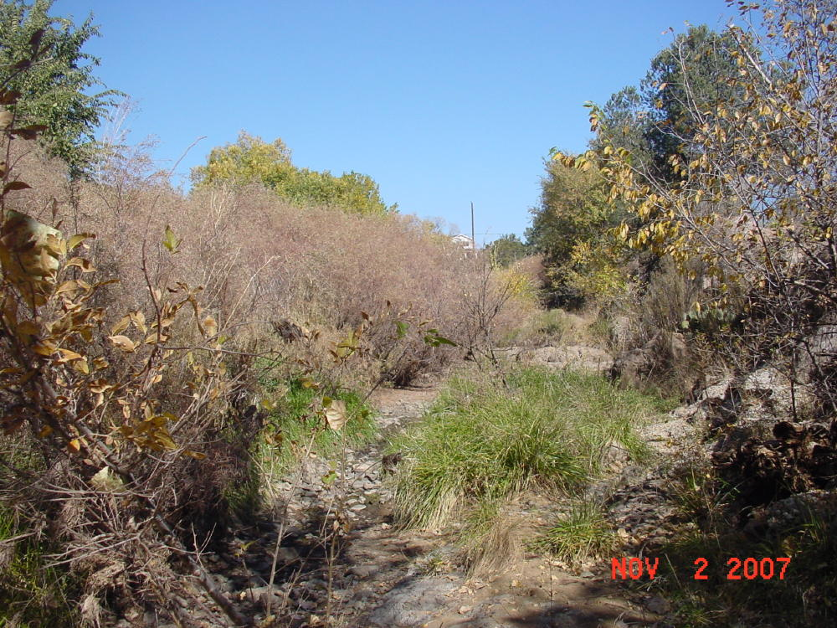

(NMED SWQB Image)

**Image 3.** View of Pinos Altos Creek downstream of the Pine Street low water crossing.

**Cottonwood Creek** is located immediately west of Pinos Alto Creek and is the smallest of the named watercourses draining the Silver City Watershed. Past impacts include livestock grazing and wood cutting. Current land use is residential housing. At least one short reach of Cottonwood Creek appears perennial and hosts a small but robust area of willow and cottonwood (Image4).

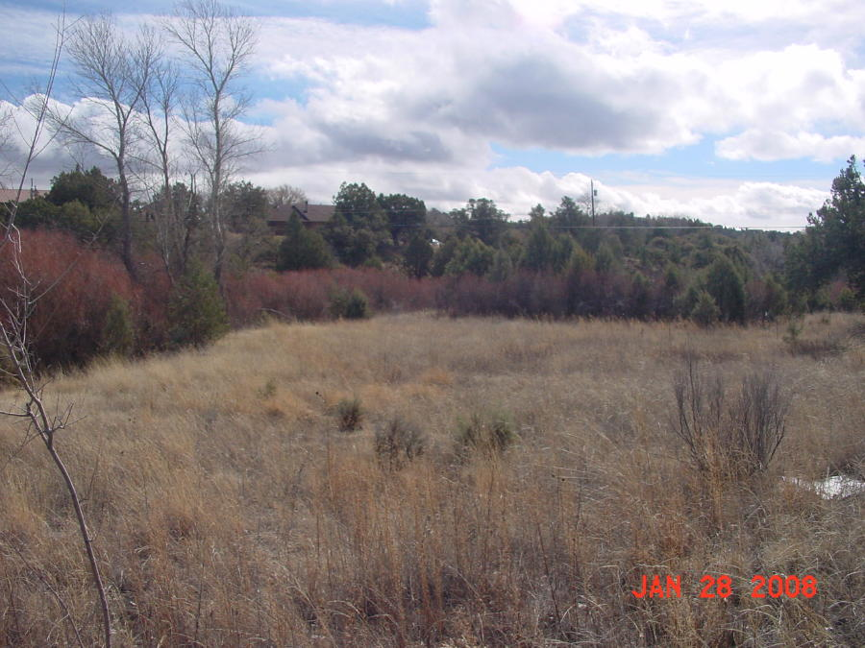

(NMED SWQB Image)

**Image 4.** View of remnant wetland and riparian resources on Cottonwood Creek. With non-native species mostly absent this area is in very good condition and provides open space for the public and habitat for wildlife.

**Little Walnut Creek** is a perennial interrupted stream draining the northern most part of the Silver City Watershed (Image5). This part of the watershed also experienced serious overgrazing, extensive wood cutting, and mining activities over the past 125 years. The primary land use today is residential housing in the lower part of the drainage. The upper area is within the Gila National Forest (but includes some private in-holdings) and is currently used for recreation and managed livestock grazing. Little Walnut Creek also drains the southern and southwestern parts of the Pinos Altos Mining District and, despite reclamation of the Cleveland Mill site by the EPA in the mid-1990s, many smaller inactive mines, waste rock piles, and mill tailings are present. The remaining wetlands and riparian resources in the Little Walnut Creek area are generally confined to short perennial reaches of the stream.

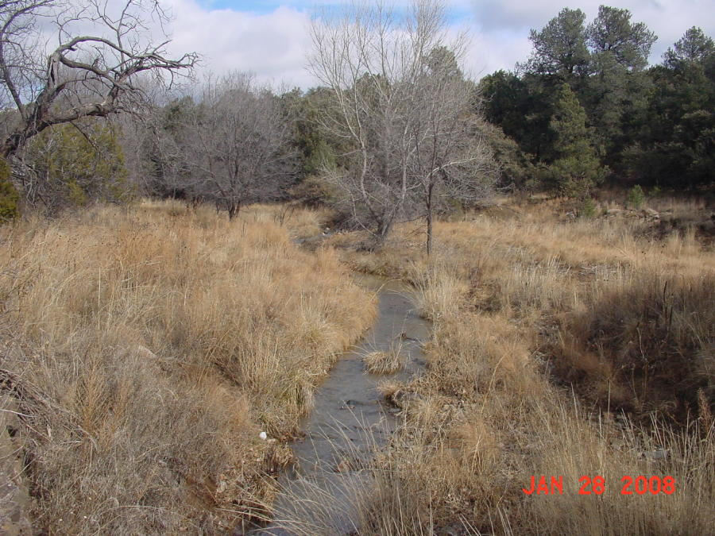

(NMED SWQB Image)

**Image 5.** Little Walnut Creek on the north end of town.

**Silva Creek** is a perennial interrupted stream draining the northwestern and western parts of the Silver City Watershed (Image6). The northern and western edges of the drainage are within the Gila National Forest and land uses include managed livestock grazing and recreational activities. The lower part of Silva Creek is mostly residential housing. The remaining wetlands and riparian resources in Silva Creek area are generally confined to short perennial reaches of the stream.

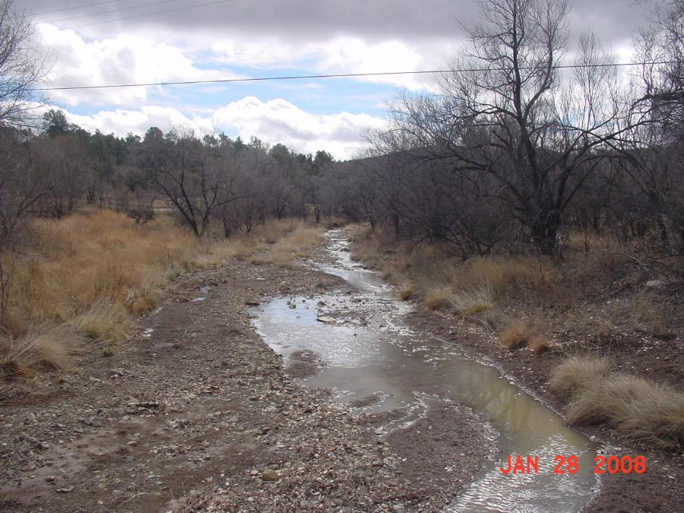

(NMED SWQB Image)

**Image 6.** View of Silva Creek below the confluence with Little Walnut Creek.

**San Vicente Creek** is a perennial interrupted stream and the only watercourse in the Silver City Watershed known to support a fishery. San Vicente Creek begins at the confluence of Pinos Altos Creek and Silva Creek in the Historic District of Silver City and eventually drains to the main stem of the Mimbres River about 30 miles southeast of Silver City. The SWQB established two water quality monitoring stations along the perennial portion of San Vicente Creek for the 2002 Mimbres Basin Intensive Water Quality Survey. Results from electro-shocking determined that at least two species of dace occur in the perennial reach of the stream. The stream is deeply incised as it passes through the Historic District of Silver City and is commonly referred to as “The Big Ditch” (Image7). San Vicente Creek experienced significant impacts from historic land management practices. Extreme overgrazing and wood cutting denuded the watershed of most vegetation prior to 1900. Subsequent flooding incised the old cienega to bedrock destroying what used to be Main Street. The Silver City Reduction Works was located just downstream of the Big Ditch and historic photographs of the area show some of the impacts from the early mining days (see historic Image8a). Some wetlands and riparian resources have recovered significantly from this period (see recent Image8b).

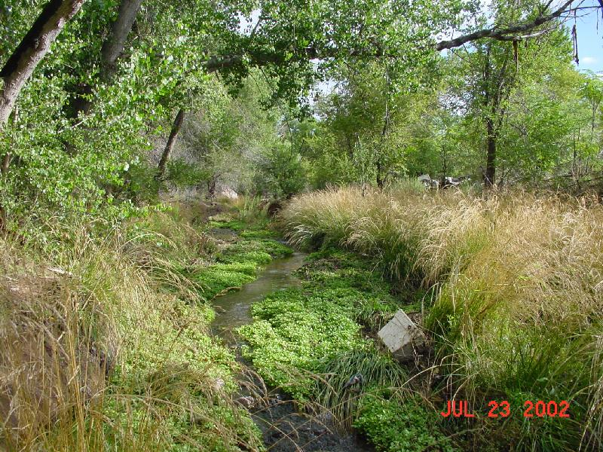

(NMED SWQB Image)

**Image 7.** San Vicente Creek downstream of the Big Ditch and upstream of the historic Silver City Reduction Works.

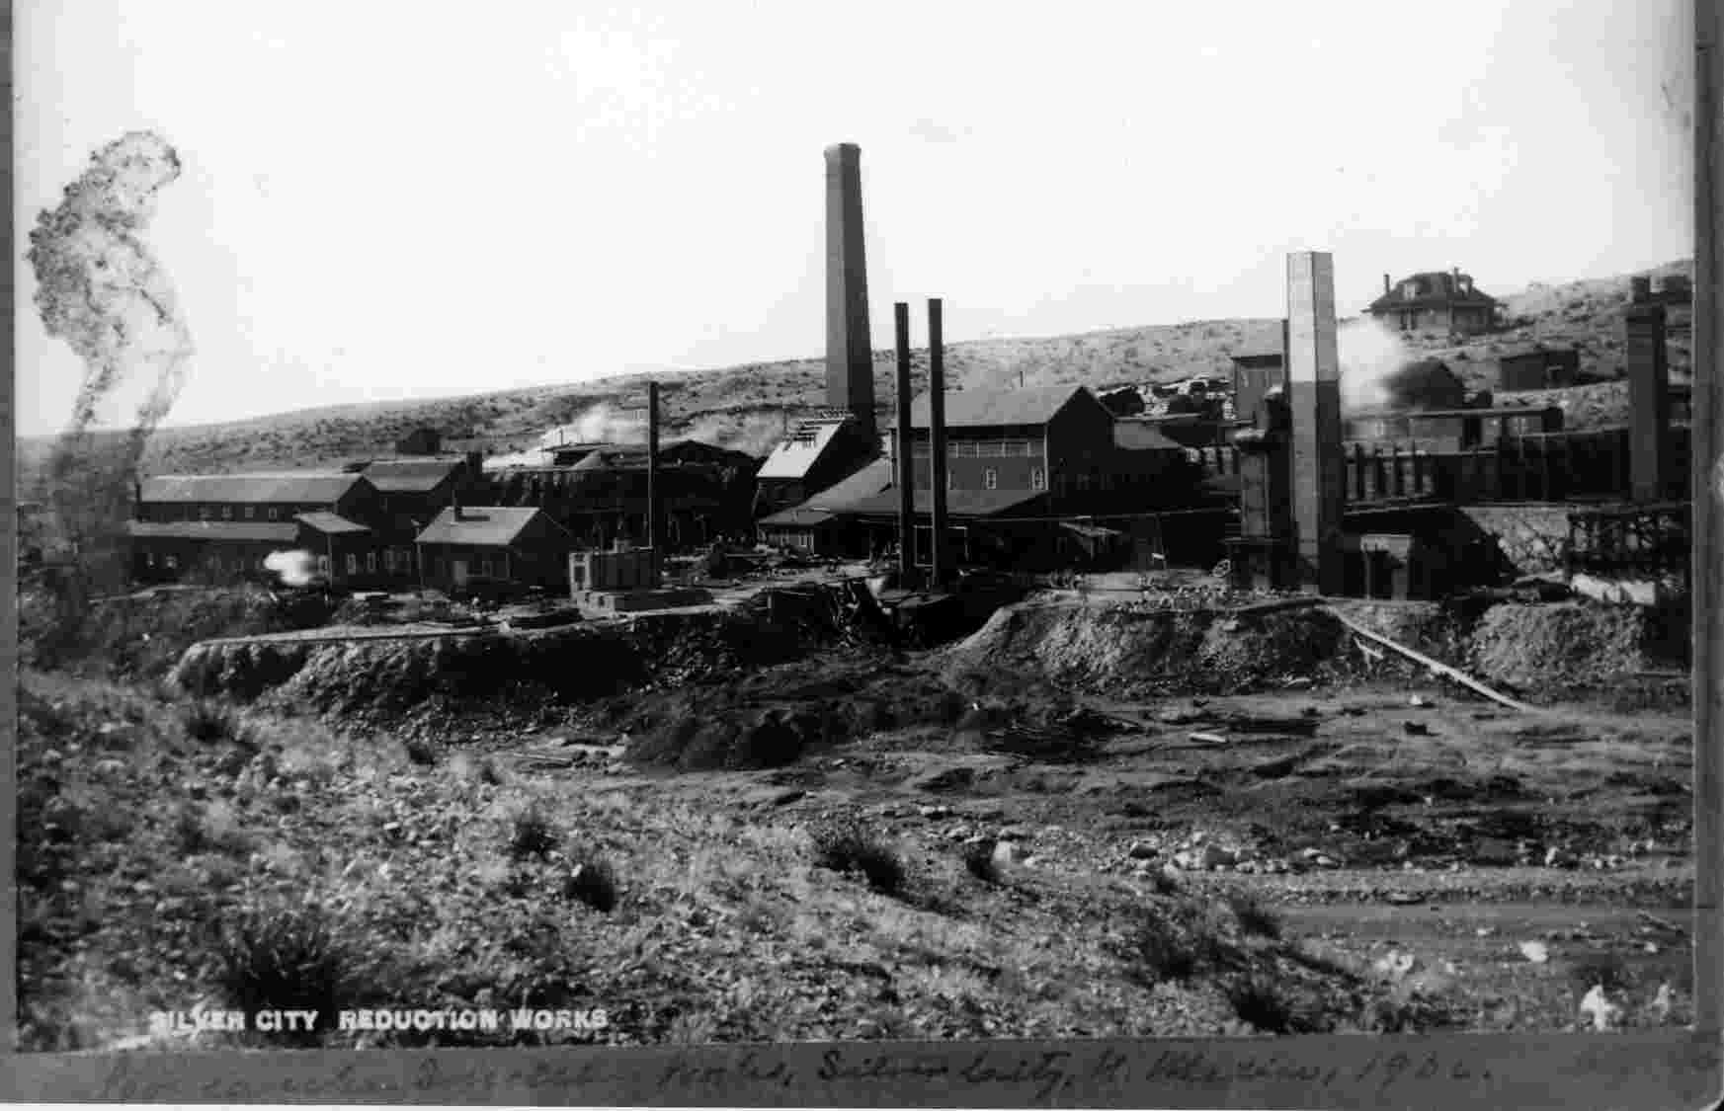

(Silver City Museum Image)

**Image 8a.** Silver City Reduction Works (about 1906) with San Vicente Creek in the low area seen in the lower right of the image. The SC Reduction Works included ore crushing mills, concentrators, and a smelter.

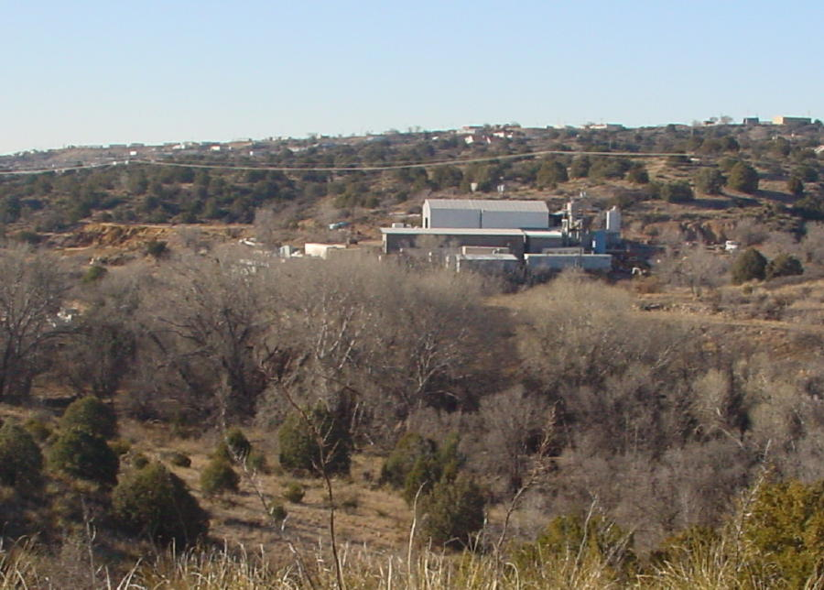

(NMED SWQB Image)

**Image 8b.** View of San Vicente Creek with a perspective similar to the previous historic image of the Silver City Reduction Works. Slag and mill tailings from the old smelter still exist on the site but are obscured by the trees in this image.

Additional isolated wetlands, riparian areas, and springs do occur within the Silver City Watershed that have not been fully assessed. For example, an un-named watercourse near the Senior Center between Boston Hill and San Vicente Creek does contain some riparian vegetation and has potential for wetland restoration (Image9).

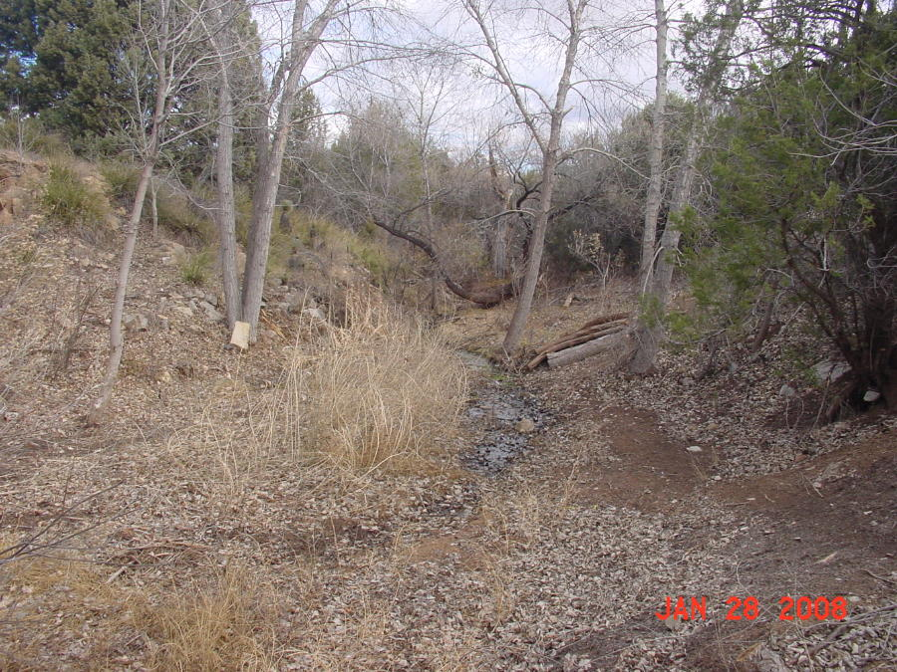

(NMED SWQB Image)

**Image 9.** La Capilla wetland area.

**Threatened and Endangered Species**

There are 45 species listed as endangered, threatened, or as species of concern that occur in Grant County (Appendix D Grant County Species List). The Southwestern New Mexico Audubon Society has been conducting an inventory of birds of San Vicente Creek and the Gila Native Plant Society is compiling a list of plants in the same area.

**Vegetation**

Overall upland vegetation in the Silver City Watershed has increased from 100 years ago as evidenced by comparing historic photographs to current photographs of the area. The surrounding upland vegetation is predominantly ponderosa pine (*Pinus ponderosa*) forests and oak (*Quercus sp.*)woodlands at higher elevations along the northern and western parts of the Silver City Watershed. Upland vegetation in the eastern and central parts of the watershed principally consists of oak–juniper (*Juniperus sp.)* woodlands. The southern part of the watershed uplands are composed of desert scrub and grasslands (McNab and Avers 1994).

Based on historic photographs, riparian vegetation has also improved (see Images8a and 8b again). The potential for successful restoration of riverine wetlands and stream riparian areas is encouraging based on the resiliency and recovery of riparian vegetation in San Vicente Arroyo. Proposed restoration efforts should concentrate on vegetation management (removal of non-native species and replanting of native wetland/riparian species) and protection of existing wetland resources.

Wetland and riparian plant associations are likely similar to associations reported in Riparian/Wetland Vegetation Communities in New Mexico: Gila, San Francisco, and Mimbres Watersheds (Durkin et al 1996). Un-impacted sites are rare or non-existent and therefore reference conditions are difficult to document.

**Threats and Impairments**

**Historic Impacts** – The Silver City Watershed has experienced significant impacts from historical land use activities that continue to affect the watershed today

One of the most dramatic episodes of erosion in the historic period occurred in the San Vicente Creek. In 1895 floodwaters 12 feet high ran through the heart of downtown (Alford 1982). When the waters receded the next day, Silver City was left with a ditch 35 feet below street level. A second flood in 1903 deepened the ditch to 55 feet (Image10). Historical data suggest that the loss of vegetation cover was severely impacted by land misuse just prior to the event and this fact rather than any unusually heavy rain was the primary causal factor.

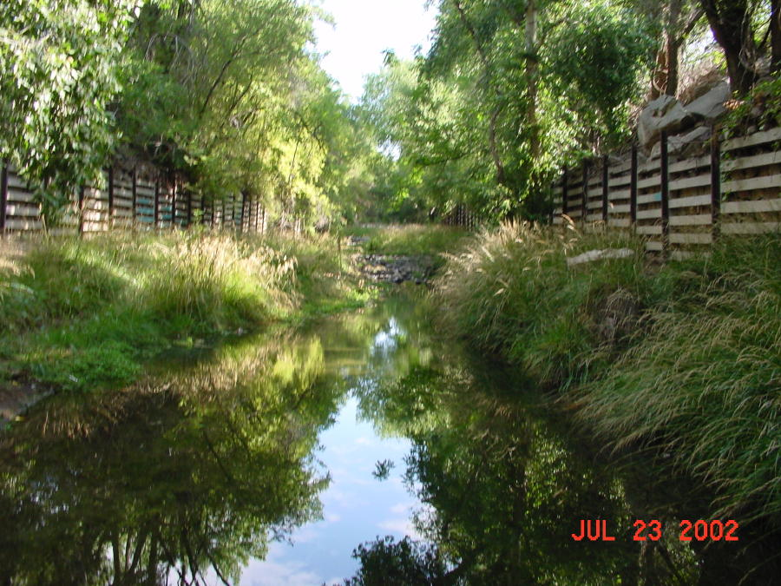

(NMED SWQB Image)

**Image 10.** The Big Ditch reach of San Vicente Creek at the 6th Street Big Ditch Park.

Areas adjacent to San Vicente Creek in the reach downstream of the Big Ditch include historic mill tailings, smelter slag, and unlined landfills that may impact water quality. Historic mines and mill tailing may also impact Maudes Canyon, Pinos Altos Creek, Little Walnut Creek, and Silva Creek. These impacts could include increased fine sediment, increased metals, and increased total dissolved solid content in surface water.

**Urban Development** – A significant threat to the remaining wetlands in the Silver City Watershed is urban development and encroachment. One example of encroachment was the placement of rip rap gabion baskets along the bank of Pinos Altos Creek at 32nd Street for erosion control. An erosion control structure was probably unnecessary until loose fill from an adjacent construction site was pushed on to the bank and into the channel. The basket structure has already failed (see Image11a) and photographs during two major flood events in 1999 indicate that the bedrock bank was unaffected by flood-related bank erosion prior to construction. The structure reduced the existing cross sectional area that floods must pass through thus increasing the flood stage, water velocity, and stress on the opposite bank. The opposite bank is not bedrock but rather fill material which the Town of Silver City later needed to repair (Image11b).

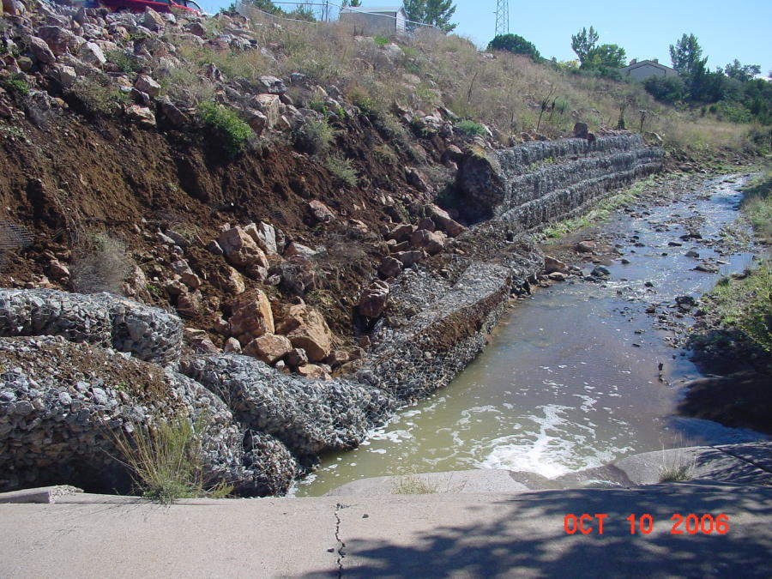

(NMED SWQB Image)

**Image 11a.** Failed gabion baskets installed on the east side of Pinos Altos Creek immediately downstream of 32nd Street.

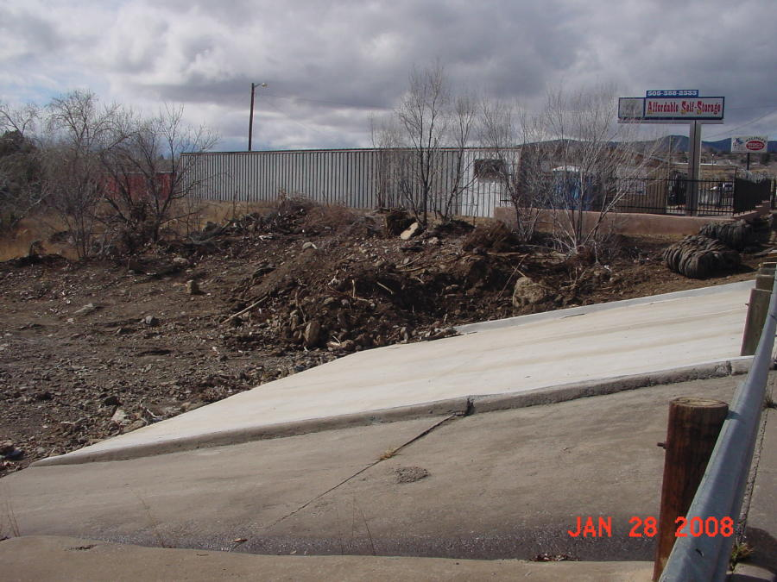

(NMED SWQB Image)

**Image 11b.** Opposite bank to the failed gabions at 32nd and Pinos Altos Creek.

Another important urbanization issue is trash and disposal of liquids to storm drains and streets that eventually reach the creeks (Image12). The Town of Silver City is addressing this problem through community volunteer efforts and Youth Conservation Corps projects.

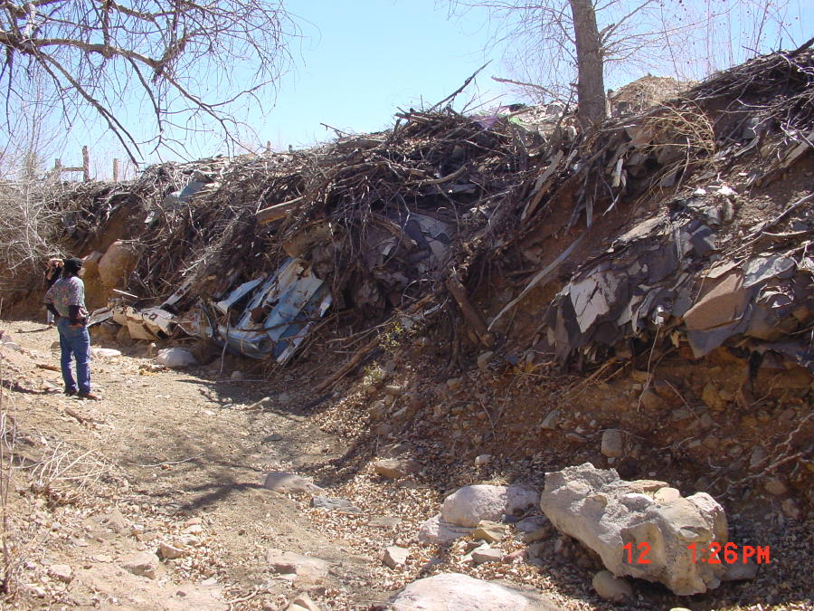

**Image 12.** Cottonwood Creek above the confluence with Silva Creek. A typical practice in the recent past was to stabilize eroding banks with whatever trash was available.

**Non-native Species** – The introduction of salt cedar, Russian olive, and Siberian elm into New Mexico in the early 1900s has resulted in profound changes to riparian forests and nearby areas (Shurlock 1987). Long-term management is needed to address the continued spread of exotic weeds and associated adverse consequences to wetland and riparian areas (US Forest Service 2004).

Invasive non-native species such as salt cedar (*Tamarix sp.),* Siberian elm (*Ulmus pumila*), Russian olive (*Elaeagnus sp.),* and Tree of Heaven (Ailanthus altissima) are present in the wetland and riparian areas but Siberian elm and Tree of Heaven are the most common non-native woody species in and along the riverine wetlands and riparian areas. Salt Cedar is a minor component of the non-native invasive woody riparian plant community but effort should be undertaken to prevent it from spreading. Appropriate native woody riparian species for restoration efforts should include Goodding’s willow (*Salix gooddingii*,) Fremont cottonwood (*Populus fremontii*), boxelder (*Acer negundo*), velvet ash (*Fraxnus velutina*), and Arizona walnut (*Juglans major*). Jasmine *(Jasminum* sp.) is a fairly established shrub along some of the drainages in Silver City. Additional monitoring and assessment is required to determine the type and extent of non-native species that occupy wetland and riparian areas in the Silver City Watershed.

**Education and Outreach**

Education and outreach is critical component in the restoration and protection of riverine wetland and riparian areas. The Gila Conservation Education Center, Inc. (GCEC) is local group organized for educational, scientific, and charitable purposes within the meaning of section 501(c)(3) of the Internal Revenue Code of 1986, as amended. The mission of the GCEC is to promote a conservation ethic in Southwest New Mexico through education, example and involvement. The vision of the GCEC is a community that understands, appreciates, and participates in natural resource conservation. The GCEC can provide valuable expertise in conducting an education and outreach program for wetlands in the Silver City Watershed. The GCEC is willing to participate in wetland inventory and monitoring projects as well implementing an outreach/education program aimed at wetlands and riparian areas in the Silver City Watershed. The GCEC has extensive experience in outreach and education programs with volunteers and staff possessing significant academic backgrounds and close connections to the community. The ability of the GCEC to mobilize volunteers willing to participate in conservation projects would provide considerable non-federal matching funds for cost share grants.

**Local Initiatives**

The purpose of the New Mexico **Youth Conservation Corps** (YCC) Act is to employ young persons in public projects that conserve New Mexico's natural resources and provide community benefits. The YCC is administratively attached to the Energy, Minerals and Natural Resources Department (EMNRD). In 2006, the Town of Silver City engaged the YCC to clean up trash, reduce fire threat from down and dead vegetation, and identify erosion prone areas and implement erosion control along the banks of Pinos Altos Creek from US Highway 180 to the confluence of Pinos Altos Creek and Silva Creek. The YCC could be engaged in the future for wetland/riparian restoration projects in the Silver City Watershed.

Brownfields are industrial and commercial sites that are abandoned or underutilized because of contamination. In 2000, the U.S. Environmental Protection Agency awarded the Town of Silver City a $200,000 **Brownfields Demonstration Pilot Grant** and an additional $50,000 grant to evaluate green space opportunities for the Town’s brownfields properties including the Boston Hill mining area.

In 2002, the Silver City Town Council approved a **Trails and Open Spaces Plan** to guide in the implementation and creation of a trails and open spaces network with Boston Hill identified as the top priority. Also in 2002, the Town was awarded a $38,500 grant from the EMNRD, with concurrence from the Federal Highway Administration (FHWA), to develop a trail system on the Boston Hill Open Space.

The **Maudes Canyon** **Clean Water Act 319 non-point source pollution project** was implemented by the New Mexico State Land Office (NMSLO) in cooperation with Western New Mexico University Department of Natural Sciences (WNMU) & the Gila Chapter of the New Mexico Native Plant Society (NPS). This tributary was selected by the NMSLO as an area to demonstrate land management practices that improve and sustain water quality and wildlife habitat. The riparian zone is a lotic system with riparian obligate vegetation such as willow and cottonwood. The project included restoration plantings for increased soil stabilization, non-native species removal to help reduce water loss, fencing installation to prevent degradation from off-road vehicle use, monitoring of baseline data, brush control, and outreach and education initiatives.

**Potential Funding Sources**

CWA Section 319 Watershed Restoration Grants

CWA Section 104(b)(3) Wetland Grants

EPA Environmental Education grants

State of NM River Ecosystem Restoration Initiative Grants

U.S. Fish and Wildlife Service Partners Program Grants

New Mexico Water Trust Board Grants

National Fish and Wildlife Foundation grants

PNM Foundation

NM State Forestry Re-Leaf program (TOSC lands)

NM Recreational Trails grants

Town of Silver City

Individual donations and in-kind services

**Inventory and Monitoring**

One of the first priorities for the Silver City Watershed Wetland Action Plan should be a GPS inventory of the location, extent, and condition of wetlands, riparian areas, and riparian buffers. Based on a conservative estimate of one percent of the watershed area consisting of riverine wetlands and riparian areas, the Silver City Watershed has a minimum of approximately 200 acres of wetlands and riparian areas with restoration potential. A description of associated flora and fauna and the existing condition and the potential for restoration should be described during this inventory. Ongoing monitoring of the composition and condition of the wetland and riparian plant community, hydrologic function, and development of hydric soils could become a basic component of a wetland education and outreach program. Monitoring and education/outreach programs can (and should be) complimentary to one another.

The SWQB has established two water quality monitoring sites on San Vicente Arroyo as part of an intensive water quality survey of the Mimbres Basin Watershed conducted in 2002. The survey results were assessed with respect to State of New Mexico water quality standards. Relevant survey data and the assessment are available from the SWQB.

**Site Prioritization and Proposed Projects**

A Wetland Action Plan requires a list of proposed projects to protect, restore, enhance and create new wetlands as a required element of a Wetlands Action Plan. Two areas with high priority for restoration are Pinos Altos Creek north of US Highway 180 and San Vicente Arroyo immediately downstream of the Big Ditch. Possible projects to be developed include the following suggestions from stakeholders:

1) A baseline inventory of wetlands and riparian areas in the Silver City Watershed.

A baseline inventory of location, extent, condition, and restoration potential of all wetland, riparian areas, and riparian buffers in the Silver City Watershed is necessary. A description of associated flora and fauna should be conducted as well as the establishment of permanent photograph documentation points. An inventory would assist in prioritization of areas needing protection and restoration.

2) Protect extant wetland and riparian areas in the Silver City Watershed.

A project to protect existing wetland and riparian resources within the Silver City Watershed should be developed. This project could include implementing conservation easements and the purchase of property consisting of channels, banks, floodplains, wetlands, and riparian areas. The Land Conservation Incentives Act of New Mexico offers a tax credit of up to $100,000 per year to anyone donating a qualified fee interest or conservation easement to an open space program, environmental organization or government entity. The credit is for 50% of the fair market value of the land and may be carried forward for twenty successive years. Qualifying land or easements must be donated for natural resource, open space, biodiversity conservation, agricultural, watershed or historic preservation. The New Mexico conservation easement tax credit is non-transferable and applies in addition to federal tax benefits. Conservation easements with private landowners and outright purchase of land by the Town of Silver City could provide potential non-federal in-kind match for a variety of federal grants. The Town of Silver City has identified for acquisition a 40 acre parcel of land in San Vicente Arroyo that would add valuable open space and encompass historic wetlands of high restoration potential.

3) Restore degraded wetland and riparian areas in the Silver City Watershed.

A project should be developed to restore riverine wetland and riparian areas by removing non-native species and planting native species. Areas with perennial or perennial interrupted hydrology would be planted with a variety of native plant species to increase diversity, including trees, shrubs, grasses and forbs. In the Silver City Watershed, sites with the greatest potential for restoration possess the key critical component – reliable water supply. Restoration projects would thus have the greatest chance for success along perennial reaches of Pinos Altos Creek between US Highway 180 and 32nd Street and along perennial reaches of San Vicente Arroyo downstream of the Big Ditch.

4) Create trails and interpretive signs.

A project should be developed to create trails and interpretive signs to educate local citizens and visitors to Silver City about the value and function of riverine wetlands and riparian areas. This initiative would also increase educational opportunities with local schools by providing outdoor classrooms.

5) Address bank erosion.

A project should be developed to address bank erosion problems along Pinos Altos Creek at storm water outfalls for thunderstorm runoff originating from impervious urban surfaces. This project is most needed from the confluence of Pinos Altos and Silva Creeks upstream to 32nd Street.

6) Trash and hazardous waste disposal education.

An educational program should be designed to inform local citizens on proper disposal of trash and hazardous waste to prevent water pollution in the Silver City Watershed. A storm water drain stencil project could be developed to increase citizen awareness and prevent introduction of toxic and hazardous materials to the receiving watercourses draining to San Vicente Arroyo. This project work could be performed by local schools and volunteers providing potential non-federal in-kind match for a variety of grants.

7) Restore the old Ancheta Landfill site.

A project to restore the old Ancheta landfill should be developed. The Ancheta landfill is an unlined landfill located immediately adjacent to San Vicente Arroyo downstream of the Big Ditch. The material in the landfill should be removed and the area restored with wetland and riparian vegetation.

8) Remove/reclaim mill tailings at the old Silver City Reduction Works site.

**References**

John J. Alford, 1982, San Vicente Arroyo, Annals of the Association of American Geographers 72 (3), 398–403

Cunningham, J. E., 1974, Geologic maps and sections of Silver City Quadrangle, New Mexico: NM Bureau of Mines and Mineral Resources, GM-30

Dick-Peddie, William A., 1993, New Mexico Vegetation: Past, Present, and Future, University of New Mexico Press, 244 p.

Durkin, P. et al, 1996, Riparian/Wetland Vegetation Communities in New Mexico: Gila, San Francisco, and Mimbres Watersheds, New Mexico Natural Heritage Program, Department of Biology, University of New Mexico

Griffith, G.E., et al, 2006, Ecoregions of New Mexico: U.S. Geological Survey

Langbein, W. B. and others, 1947, Manual of Hydrology: Part 1. General Surface-Water Techniques, Methods, and practices of the Geological Survey, Geological Survey Water-Supply Paper 1541-A

McNab, W.H. and Avers, P.E. 1994. Ecological subregions of the United States: section

descriptions. Prepared in cooperation with regional compilers and the ECOMAP team of

the Forest Service. USDA Forest Service, Ecosystem Management. Washington, DC.

Meinzer, O. E., 1923, Outline of ground-water hydrology, with definitions: U.S. Geol. Survey Water-Supply Paper 494, 71 p.

Minckley, W. L., & Brown, D.E. 1982, Wetlands In Biotic Communities of the American Southwest–United States and Mexico, special issue of Desert Plants, Vol. 4 (D. E. Brown, Ed.)

New Mexico Environment Department Surface Water Quality Bureau, 2004, Water Quality Assessment Summary of the Mimbres Watershed, NMED-SWQ-03/04

Parham, T. L., Paetzold, R., and Soulders, C. E., 1983 Soil Survey of Grant County, New Mexico Central and Southern Parts, U.S. Department of Agriculture.

Shurlock, D. 1987. The Rio Grande bosque: ever changing. New Mexico Historical Review. 131-141 p.

U.S. Army Corps of Engineers, 1987, Wetlands Delineation Manual

U.S. Forest Service, 2004, Strategy for Long-Term Management of Exotic Trees in Riparian Areas for New Mexico’s Five River Systems, 2005-2014

Wooton, E.O. 1908. The Range Problem in New Mexico [Bulletin No. 66 of the Agricultural Experiment Station] Albuquerque: Albuquerque Morning Journal

**APPENDIX A**

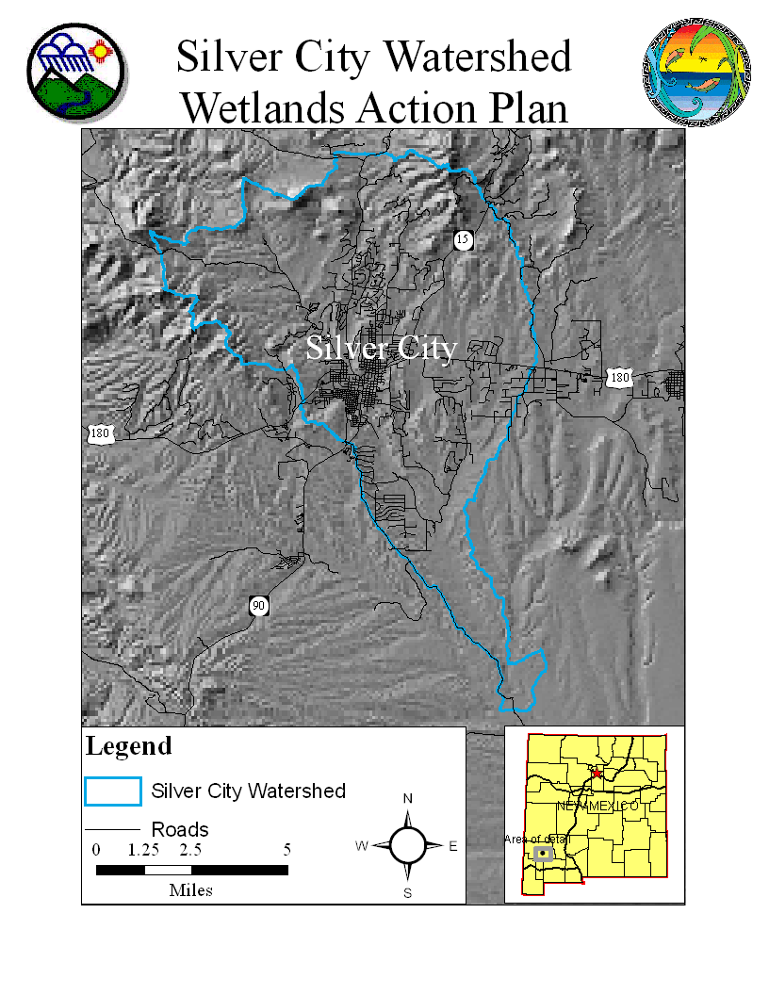

# Appendix B Climate Data

# Climate data from Western Regional Climate Center

# SILVER CITY, NEW MEXICO Monthly Climate Summary 1961-1990

|  |  |  |  |  |  |  |  |  |  |  |  |  |  |
| --- | --- | --- | --- | --- | --- | --- | --- | --- | --- | --- | --- | --- | --- |
|  | Jan | Feb | Mar | Apr | May | Jun | Jul | Aug | Sep | Oct | Nov | Dec | Annual |
| Average Max. Temperature (F) | 51.7 | 55.8 | 59.1 | 70.7 | 78.4 | 85.2 | 87.7 | 85.6 | 79.7 | 72.6 | 58.7 | 54.1 | 70.2 |
| Average Min. Temperature (F) | 21.0 | 24.7 | 28.2 | 37.7 | 44.7 | 52.4 | 58.9 | 58.0 | 51.7 | 41.2 | 30.8 | 25.6 | 39.7 |
| Average Total Precipitation (in.) | 1.22 | 0.90 | 0.74 | 0.30 | 0.12 | 0.98 | 3.32 | 2.51 | 2.85 | 1.11 | 1.58 | 1.85 | 17.48 |

### 1961 - 1990 Temperature and Precipitation Chart

### 

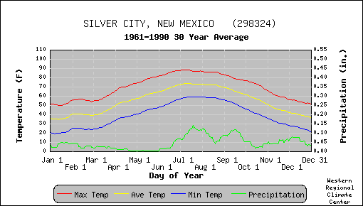

# Appendix C Soils

**Soil Orders**

The NRCS National Soils Survey map indicates four soil orders occurring in the Silver City Watershed. A description of these four orders and of Mollisols (which were identified in Durkin 1996 as occurring in the general area) follows:

**Alfisols** - The soils in this order have markers of processes that translocate silicate clays without excessive depletion of bases and without dominance of the processes that lead to the formation of a mollic epipedon. The unique properties of Alfisols are a combination of an ochric or umbric epipedon, an argillic or natric horizon, a medium to high supply of bases in the soils, and water available to mesophytic plants for more than half the year or more than 3 consecutive months during a warm season. Because these soils have water and bases, they are, as a whole, intensively used.

**Aridisols** - Aridisols are primarily soils of arid areas. The unique properties common to Aridisols are a combination of a lack of water available to mesophytic plants for very extended periods, one or more pedogenic horizons, a surface horizon or horizons not significantly darkened by humus, and absence of deep, wide cracks (see Vertisols) and andic soil properties (see Andisols). Aridisols have no available water during most of the time that the soils are warm enough for plant growth and they never have water continuously available for as long as 90 days when the soil temperature is above 8 C°. The vegetation in many areas consists of scattered ephemeral grasses and forbs, cacti, and xerophytic shrubs. Some Aridisols provide limited grazing.

**Entisols** - The unique properties common to Entisols are dominance of mineral soil materials and absence of distinct pedogenic horizons. The absence of features of any major set of soil forming processes is itself an important distinction. There can be no accessory characteristics. Entisols are soils in the sense that they support plants, but they may be in any climate and under any vegetation.

**Inceptisols** - Inceptisols have a wide range of characteristics and occur in a wide variety of climates. They can form in almost any environment, except for an arid environment, and the comparable differences in vegetation are great. Inceptisols can grade toward any other soil order and occur on a variety of landforms. The unique properties of Inceptisols are a combination of water available to plants for more than half the year or more than 3 consecutive months during a warm season and one or more pedogenic horizons of alteration or concentration with little accumulation of translocated materials other than carbonates or amorphous silica.

**Mollisols** - The unique properties of Mollisols are a combination of a very dark brown to black surface horizon (mollic epipedon) that makes up more than one-third of the combined thickness of the A and B horizons or that is more than 25 cm thick and that has structure or is not hard or very hard when dry; a dominance of calcium among the extractable cations in the A and B horizons; a dominance of crystalline clay minerals of moderate or high cation-exchange capacity; and less than 30 percent clay in some horizon above 50 cm if the soils have deep, wide cracks (1 cm or more wide) above this depth at some season. Mollisols characteristically form under grass in climates that have a moderate to pronounced seasonal moisture deficit. Some Mollisols, however, formed under a forest ecosystem, and a few formed in marshes or in marls in humid climates. Mollisols are extensive soils on the steppes of Europe, Asia, North America, and South America.

The Soil Survey of Grant County includes descriptions of soil taxonomic units with potential for wetland plant communities. Some of these soils are “so intricately intermingled that it was not practical to map them separately at the scale used”. Excerpts from the survey about these soils follow:

**Manzano -** Two mapping units ofManzano Loam, 0 to 1 percent slopes and 1 to 3 percent slopes (two soil units). Both mapping units are deep and well drained soils on flood plains and/or upland valleys. The soils are formed in alluvium derived of mixed sources. Typically the surface layer is brown to very dark grayish brown loam. Included in both mapping units are small areas of Haverson, Paymaster, and Ellicott soils on flood Plains; Ruidoso soils on alluvial fans; and Manzano soils that have a high water table.

**Paymaster -** This soil is described as deep and well drained, 0 to 1 percent slope, sandy to fine sandy loam. Included in this mapping unit are soils similar to Paymaster but are wet. Typically the surface layer is dark grayish brown sandy loam. Permeability is moderately rapid and available water capacity is high. Runoff is slow and water erosion is slight. This soil map unit usually includes Ellicott soils as a soil complex.

**Ellicott** - This soil is described as deep and somewhat excessively drained, 0 to 1 percent slope, sandy to fine sandy loam. Included in this mapping unit are soils similar to Ellicott but are wet. Typically the surface layer is grayish brown gravelly sand. Permeability is rapid and available water capacity is low. Runoff is slow and water erosion is slight. This soil map unit is usually combined with Paymaster soils as a complex.

**Stirk Varient** - This soil is a silty clay loam on 0 to 1 percent slopes. It is a deep and moderately well drained soil on flood plains and alluvial fans. It formed in alluvium from mixed sources and the surface layer is typically a light brownish gray silty clay loam. Permeability is very slow and available water capacity is moderate. Runoff is slow and water erosion is slight.

# Appendix D Species List

## Listed and Sensitive Species in Grant County 2007 as identified by US Fish and Wildlife Services NM Ecological Services Field Office.

|  |  |
| --- | --- |
| Total number of species: 45 |  |

|  |  |  |  |  |
| --- | --- | --- | --- | --- |
| |  |  |  |  | | --- | --- | --- | --- | | Common Name | Scientific Name | Group | Status | |
| |  |  |  |  | | --- | --- | --- | --- | | Yellow-billed cuckoo | Coccyzus americanus | Bird | Candidate | | Gila springsnail | Pyrgulopsis gilae | Mollusc - Invertebrate | Candidate | | New Mexico hotspring snail | Pyrgulopsis thermalis | Mollusc - Invertebrate | Candidate | | Northern aplomado falcon | Falco femoralis septentrionalis | Bird | Endangered | | Southwestern willow flycatcher  Designated Critical Habitat | Empidonax traillii extimus | Bird | Endangered | | Gila chub  Designated Critical Habitat | Gila intermedia | Fish | Endangered | | Gila topminnow 3 | Poeciliopsis occidentalis | Fish | Endangered | | Black-footed ferret 2 | Mustela nigripes | Mammal | Endangered | | Gray Wolf (Mexican Gray Wolf) | Canis lupus baileyi | Mammal | Endangered | | Chiricahua leopard frog | Rana chiricahuensis | Amphibian | Threatened | | Bald eagle | Haliaeetus leucocephalus | Bird | Threatened | | Mexican spotted owl  Designated Critical Habitat | Strix occidentalis lucida | Bird | Threatened | | Beautiful shiner 3 | Cyprinella formosa | Fish | Threatened | | Chihuahua chub | Gila nigrescens | Fish | Threatened | | Gila trout | Oncorhynchus gilae | Fish | Threatened | | Loach minnow  Proposed Critical Habitat | Tiaroga cobitis | Fish | Threatened | | Spikedace  Proposed Critical Habitat | Meda fulgida | Fish | Threatened | |

#### Species of Concern Species of Concern are included for planning purposes only.

|  |  |  |  |  |
| --- | --- | --- | --- | --- |
| |  |  |  |  | | --- | --- | --- | --- | | Common Name | Scientific Name | Group | Status | |
| |  |  |  |  | | --- | --- | --- | --- | | Lowland leopard frog | Rana yavapaiensis | Amphibian | Species of Concern | | Desert viceroy butterfly | Limenitis archippus obsoleta | Arthropod - Invertebrate | Species of Concern | | New Mexico silverspot butterfly | Speyeria nokomis nitocris | Arthropod - Invertebrate | Species of Concern | | American peregrine falcon | Falco peregrinus anatum | Bird | Species of Concern | | Arctic peregrine falcon | Falco peregrinus tundrius | Bird | Species of Concern | | Baird's sparrow | Ammodramus bairdii | Bird | Species of Concern | | Bell’s vireo | Vireo bellii | Bird | Species of Concern | | Common black hawk | Buteogallus anthracinus | Bird | Species of Concern | | Northern goshawk | Accipiter gentilis | Bird | Species of Concern | | Northern gray hawk | Buteo nitidus maxima | Bird | Species of Concern | | Western burrowing owl | Athene cunicularia hypugaea | Bird | Species of Concern | | Desert sucker | Catostomus clarki | Fish | Species of Concern | | Rio Grande sucker | Catostomus plebeius | Fish | Species of Concern | | Roundtail chub | Gila robusta | Fish | Species of Concern | | Sonora sucker | Catostomus insignis | Fish | Species of Concern | | Townsend's big-eared bat | Corynorhinus townsendii | Mammal | Species of Concern | | White-sided jack rabbit | Lepus callotis gaillardi | Mammal | Species of Concern | | Shortneck snaggletooth (snail) | Gastrocopta dalliana dalliana | Mollusc - Invertebrate | Species of Concern | | Desert night-blooming cereus | Cereus greggii var. greggii | Plant | Species of Concern | | Dwarf milkweed | Asclepias uncialis var. uncialis | Plant | Species of Concern | | Parish's alkali grass | Puccinellia parishii | Plant | Species of Concern | | Pinos Altos flame flower | Talinum humile | Plant | Species of Concern | | Porsild's starwort | Stellaria porsildii | Plant | Species of Concern | | San Carlos wild-buckwheat | Eriogonum capillare | Plant | Species of Concern | | Slender spiderflower | Cleome multicaulis | Plant | Species of Concern | | Wright's dogweed | Adenophyllum wrightii var. wrightii | Plant | Species of Concern | | Mexican garter snake | Thamnophis eques | Reptile | Species of Concern | | Narrowhead garter snake | Thamnophis rufipunctatus | Reptile | Species of Concern | |

|  |  |  |  |  |  |  |  |  |  |  |  |  |
| --- | --- | --- | --- | --- | --- | --- | --- | --- | --- | --- | --- | --- |
| |  |  |  |  | | --- | --- | --- | --- | | **Endangered** | Any species which is in danger of extinction throughout all or a significant portion of its range. | **Threatened** | Any species which is likely to become an endangered species within the foreseeable future throughout all or a significant portion of its range. | | **Candidate** | Candidate Species (taxa for which the Service has sufficient information to propose that they be added to list of endangered and threatened species, but the listing action has been precluded by other higher priority listing activities). | **Proposed** | Any species of fish, wildlife or plant that is proposed in the Federal Register to be listed under section 4 of the Act. This could be either proposed for endangered or threatened status. | | **Species of Concern** | Taxa for which further biological research and field study are needed to resolve their conservation status OR are considered sensitive, rare, or declining on lists maintained by Natural Heritage Programs, State wildlife agencies, other Federal agencies, or professional/academic scientific societies. Species of Concern are included for planning purposes only. | | | |

|  |  |  |  |  |  |  |  |  |  |  |  |  |  |  |  |  |
| --- | --- | --- | --- | --- | --- | --- | --- | --- | --- | --- | --- | --- | --- | --- | --- | --- |
| |  |  |  |  | | --- | --- | --- | --- | | Foot Notes: | | | | | **D** | Designated Critical Habitat. | **P** | Proposed Critical Habitat. | | **1** | Introduced population. | **3** | Extirpated in this county. | | **2** | Survey should be conducted if project involves impacts to prairie dog towns or complexes of 200-acres or more for the Gunnison's prairie dog (Cynomys gunnisoni) and/or 80-acres or more for any subspecies of Black-tailed prairie dog (Cynomys ludovicianus). A complex consists of two or more neighboring prairie dog towns within 4.3 miles (7 kilometers) of each other. | | | |